**How to set RTC time：**

1. Connect to the USART1 port of BASEX+ using the serial port tool

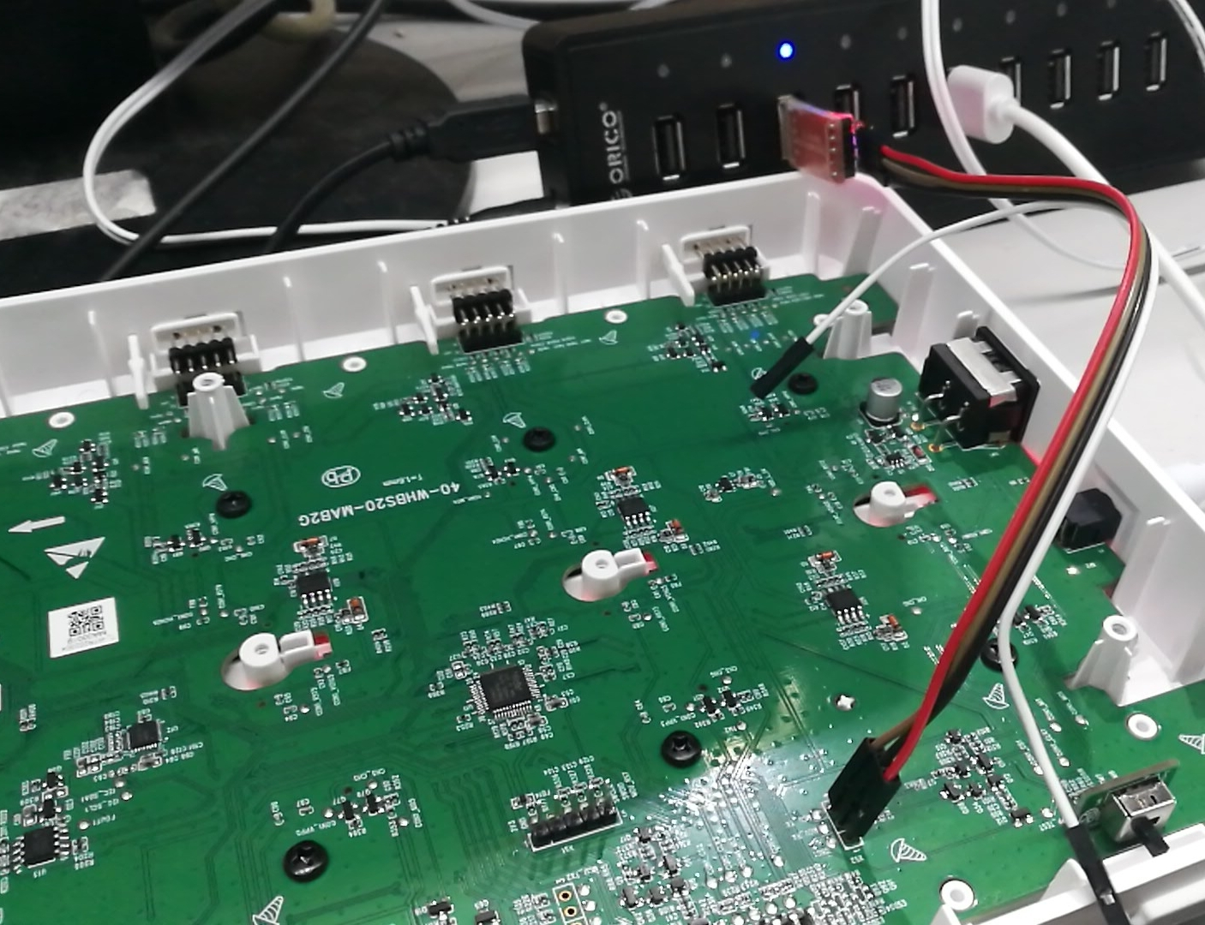

Uart1

2.When the BASEX+ user program running,Send USART command:

(1). Enter/exit the factory test

Send：

|  |  |  |  |  |
| --- | --- | --- | --- | --- |
| The frame header | Data len | order | data | Check sum |
| 0xFF 0x55 | 0x01 | 0x06 | Enter/exit | XX |

Return：

|  |  |  |  |  |
| --- | --- | --- | --- | --- |
| The frame header | Data len | order | data | Check sum |
| 0xFF 0x55 | 0x00 | 0x06 | 无 | XX |

Example:

Send： enter the factory test：FF 55 01 06 01 AC

(Note: 01 enter the factory test.Exit factory test at 00)

Return：FF 55 00 06 AC

(Note, after the instruction is executed, power outage is required to restart to take effect)

3.After a power outage and restart, BASEX+ will go to ATS mode,Send command:

(2). Set THE RTC time

Send：

|  |  |  |  |  |
| --- | --- | --- | --- | --- |
| The frame header | Data len | order | data | Check sum |
| 0xFF 0x55 | 0x08 | 0x03 | Current local time | XX |

|  |  |  |
| --- | --- | --- |
| data | type | len |
| The time zone | Uint8 | 1byte |
| years | Uint16 | 2bytes |
| month | Uint8 | 1byte |
| day | Uint8 | 1byte |
| hours | Uint8 | 1byte |
| minutes | Uint8 | 1byte |
| seconds | Uint8 | 1byte |

Return：

|  |  |  |  |  |
| --- | --- | --- | --- | --- |
| The frame header | Data len | order | data | Check sum |
| 0xFF 0x55 | 0x00 | 0x03 | no | XX |

Example:

Send：FF 55 08 03 08 0A 07 E308 0A 30 2E 5B

Return：FF 55 00 03 A9

（Note：Time zone range is 0~24，That's hexadecimal is 0x00~0x18

1~12 for west time zone：0x01~0x0c

13~24 for the eastern time zone：0x0d~0x18

Example: Beijing time is East eight area, namely 20 (0x14)

）

1. After setting the time, the time can be read directly through the following instructions, or read after power off and restart (check whether the write is successful).

(3). Query THE RTC time

Send：

|  |  |  |  |  |
| --- | --- | --- | --- | --- |
| The frame header | Data len | order | data | Check sum |
| 0xFF 0x55 | 0x00 | 0x04 | 无 | XX |

Return：

|  |  |  |  |  |
| --- | --- | --- | --- | --- |
| The frame header | Data len | order | data | Check sum |
| 0xFF 0x55 | 0x07 | 0x04 | Current RTC time | XX |

Example:

Send：FF 55 00 04 AE

Return：FF 55 07 04 14 13 0A 09 0B 01 14 B3

（Note: The time section is 14 13 0A 09 0B 01 14，

Converted to decimal, it appears as 20 19 10 09 11 01 20

Means October 9, 2019 11:01 am 20 sec)

1. Use the exit ATS command when the reading time is clear

Example:

Send： Exit factory test：FF 55 01 06 00 AD

(Note: 01 enter the factory test.Exit factory test at 00)

Return：FF 55 00 06 AC

(Note, after the instruction is executed, power outage is required to restart to take effect)

1. BASEX+ will return to user mode after another power outage and restart, and the RTC time setting process will end